Round Robin

🔁 What Is Round Robin in Load Balancing?
# Source: AI Source: Provided by: [Data Path: Persons Table -> ID Column: 1, Name_En Column: Motasem Essam] -> From: [ChatGPT] on [12/18/2025]
Round Robin is a simple and common algorithm used by load balancers to distribute incoming requests evenly across a group of servers — one after another, in a circular order.

✅ Simple Definition:
# Source: AI Source: Provided by: [Data Path: Persons Table -> ID Column: 1, Name_En Column: Motasem Essam] -> From: [ChatGPT] on [12/18/2025]
Round Robin sends requests to servers one at a time in order, like:
A → B → C → A → B → C → ...

🧠 Real-Life Analogy:
# Source: AI Source: Provided by: [Data Path: Persons Table -> ID Column: 1, Name_En Column: Motasem Essam] -> From: [ChatGPT] on [12/18/2025]
Imagine 3 cashiers (A, B, C) and customers arriving at the door:
- The first customer goes to A
- Second to B
- Third to C
- Fourth goes back to A again
- ...and so on
This keeps the load evenly spread.

🧪 Example:
# Source: AI Source: Provided by: [Data Path: Persons Table -> ID Column: 1, Name_En Column: Motasem Essam] -> From: [ChatGPT] on [12/18/2025]
Assume you have 3 servers:
- Server A
- Server B
- Server C
Incoming requests are distributed like this:
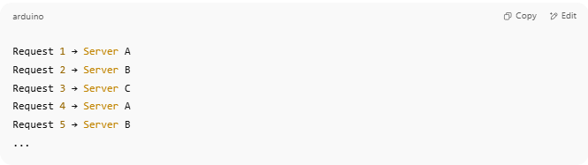
Request 1 → Server A
Request 2 → Server B
Request 3 → Server C
Request 4 → Server A
Request 5 → Server B
...

📊 Benefits of Round Robin
# Source: AI Source: Provided by: [Data Path: Persons Table -> ID Column: 1, Name_En Column: Motasem Essam] -> From: [ChatGPT] on [12/18/2025]
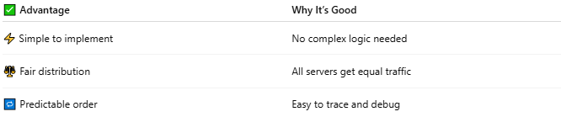

✅ Advantage | Why It’s Good
⚡ Simple to implement | No complex logic needed
⚖️ Fair distribution | All servers get equal traffic
🔁 Predictable order | Easy to trace and debug

⚠️ Limitations
# Source: AI Source: Provided by: [Data Path: Persons Table -> ID Column: 1, Name_En Column: Motasem Essam] -> From: [ChatGPT] on [12/18/2025]
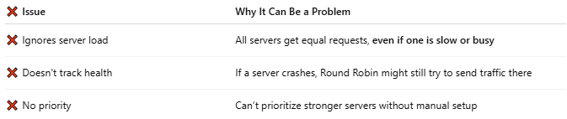

❌ Issue | Why It Can Be a Problem
❌ Ignores server load | All servers get equal requests, even if one is slow or busy
❌ Doesn't track health | If a server crashes, Round Robin might still try to send traffic there
❌ No priority | Can’t prioritize stronger servers without manual setup

📈 Variants of Round Robin
# Source: AI Source: Provided by: [Data Path: Persons Table -> ID Column: 1, Name_En Column: Motasem Essam] -> From: [ChatGPT] on [12/18/2025]

Type | What It Does
Weighted Round Robin | Gives more traffic to stronger servers
Dynamic Round Robin | Adjusts in real time based on performance

🔧 Common Use In:
# Source: AI Source: Provided by: [Data Path: Persons Table -> ID Column: 1, Name_En Column: Motasem Essam] -> From: [ChatGPT] on [12/18/2025]
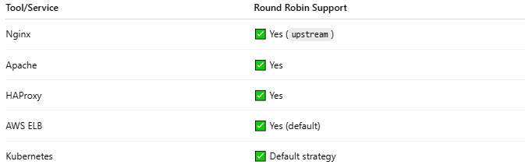

Tool/Service | Round Robin Support
Nginx | ✅ Yes (upstream)
Apache | ✅ Yes
HAProxy | ✅ Yes
AWS ELB | ✅ Yes (default)
Kubernetes | ✅ Default strategy

📌 Summary
# Source: AI Source: Provided by: [Data Path: Persons Table -> ID Column: 1, Name_En Column: Motasem Essam] -> From: [ChatGPT] on [12/18/2025]
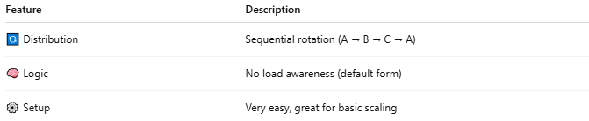

Feature | Description
🔄 Distribution | Sequential rotation (A → B → C → A)
🧠 Logic | No load awareness (default form)
⚙️ Setup | Very easy, great for basic scaling

